DATA ANALYTICS PROJECT REPORT
Project Title: Sales Performance & Customer Insights Analysis Using Synthetic Retail Data
Dataset Domain: Retail Analytics Dataset
Tools Used: | Mockaroo| Excel | SQL | Power BI |
Submission Date: 06.02.2026

Prepared by:
NAVIN .S
Data Analytics batch September 2025

TABLE OF CONTENTS
Chapter No. | Title | Page No.
1 | Introduction | 1
2 | Executive Summary | 1
3 | Problem Statement | 3
4 | Data Description | 6
5 | Tools and Technologies | 7
6 | Dataset Details (Mockaroo) | 8
7 | Data Cleaning Using Excel | 10
8 | SQL Functions Used | 11
9 | Data Visualization Using Power BI | 15
10 | Findings and Recommendations | 16
11 | Conclusion | 17

1. Executive Summary

Purpose
This project focuses on analyzing a synthetically generated retail sales dataset to identify customer purchasing behavior, product performance, and store-level insights. Using Excel, SQL, and Power BI, raw data was cleaned, transformed, and visualized to extract meaningful business insights. The final outcome includes interactive dashboards and actionable recommendations to support data-driven decision-making.

Key Highlights
- Dataset generated using Mockaroo with over 1,000+ records
- Data cleaning and transformation performed using Excel and SQL
- Interactive dashboards built using Power BI
- Business insights and recommendations derived from data analysis

Outcome
The project successfully demonstrates practical data analytics skills including data preparation, SQL querying, visualization, and insight generation for decision-making.

2. Problem Statement
Retail businesses generate transactional data daily, but without proper analysis, valuable insights remain hidden.
The objective of this project is to analyze sales data to:
- Understand customer behavior
- Identify top-performing products and categories
- Analyze store-wise and payment method trends
- Provide actionable recommendations for business improvement

. Dataset Description

Dataset Source
- Type: Synthetic dataset
- Generated Using: Mockaroo
- Records: 1,000+ rows
- Format: Excel (.xlsx)

Dataset Fields
Column Name | Description
Order_ID | Unique identifier for each order
Customer_ID | Unique identifier for each customer
Order_Date | Date when the order was placed
Customer_Name | Name of the customer
Product_Name | Name of the purchased product
Product_Category | Category of the product
Quantity | Number of units purchased
Unit_Price | Price per unit
Store_Location | Store city/region
Payment_Method | Mode of payment (Card, Cash, UPI, etc.)

Tools & Technologies Used
Tool | Usage
Mockaroo | Synthetic data generation
Excel | Data cleaning and preprocessing
SQL | Data transformation and analysis
Power BI | Data visualization and dashboard creation

Data Generation Using Mockaroo

Tool Used
Mockaroo – Synthetic Data Generation

Purpose
Mockaroo was used to generate a realistic synthetic retail dataset that simulates real-world sales transactions. This allows data analysis without using sensitive or confidential data.

Step-by-Step Data Generation Process

Step 1: Create a New Schema
- Navigate to Mockaroo
- Click on Create New Schema
- Set the number of rows to 1,000+

Step 2: Define Dataset Fields
Configure the following columns exactly as shown:
Field Name | Data Type (Mockaroo) | Description
OrderID | Row Number / Custom ID | Unique order identifier
CustomerID | Custom ID / Number | Unique customer identifier
OrderDate | Date | Order transaction date
CustomerName | Full Name | Name of the customer
ProductName | Product | Purchased product
ProductCategory | Custom List | Category of the product
Quantity | Number (1–10) | Units purchased
UnitPrice | Number (Decimal) | Price per unit
StoreLocation | City / State | Store location
PaymentMethod | Custom List | Mode of payment

Step 3: Configure Field Settings

Product_Category (Custom List)
Electronics
Clothing
Groceries
Home & Kitchen
Footwear

Payment_Method (Custom List)
Credit Card
Debit Card
UPI
Cash
Net Banking
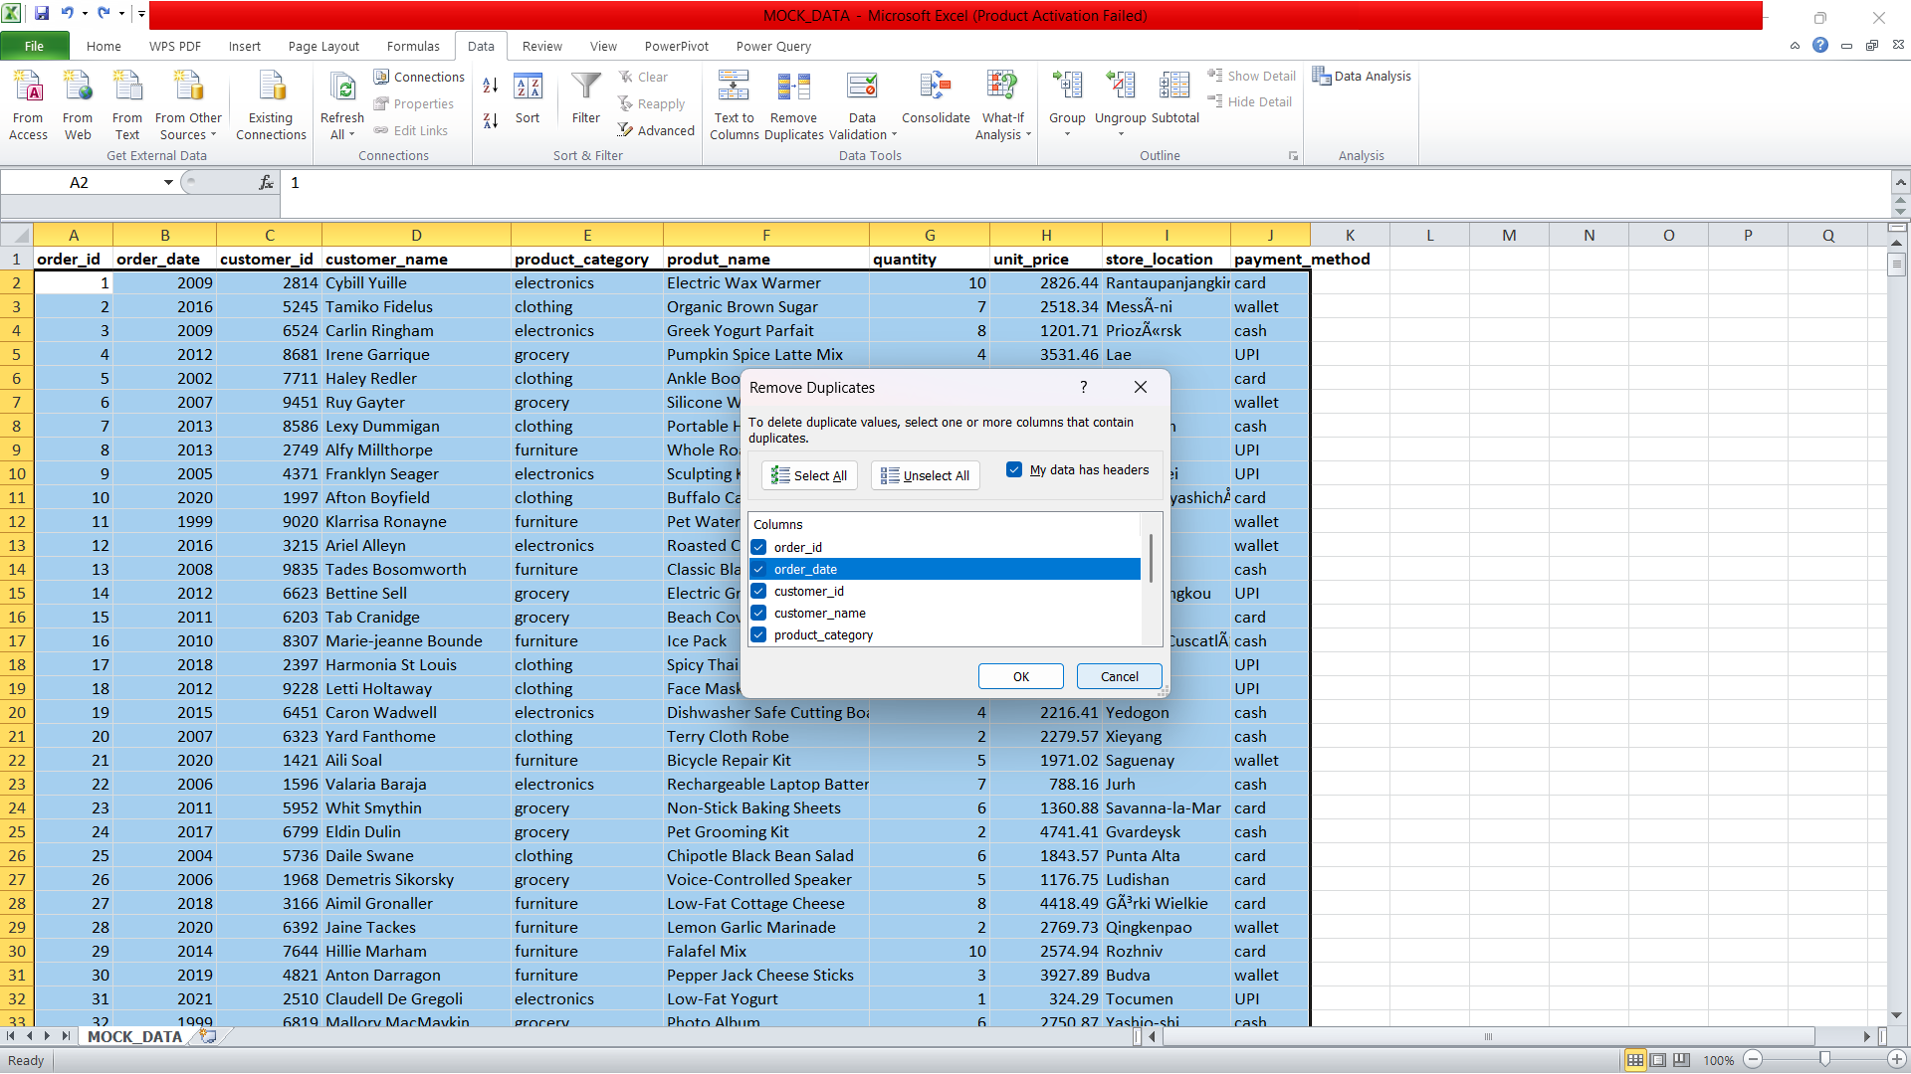

Step 4: Set Data Constraints
- Quantity: Minimum = 1, Maximum = 10
- Unit Price: Minimum = 100, Maximum = 50,000
- Order Date: Last 2 years
- Order ID: Unique values enabled

Step 5: Export Dataset
- Select Excel (.xlsx) format
- Click Download Data
- Save as:
Retail_Sales_Raw_Data.xlsx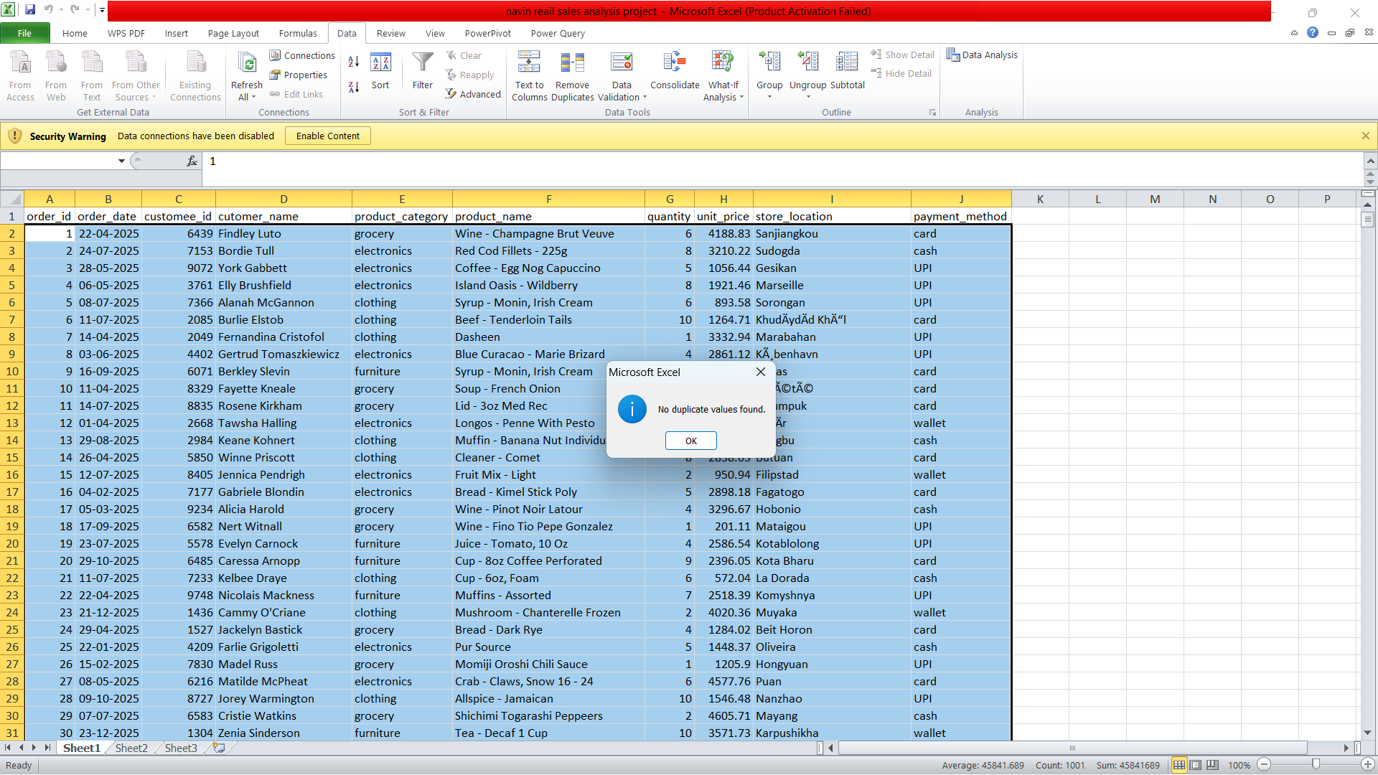

Data Validation
After generation:
- Verified uniqueness of Order_ID
- Ensured no null values
- Checked realistic pricing and quantity distribution
- Confirmed consistency between product category and pricing

Advantages of Using Mockaroo
- No real customer data used
- Customizable and scalable datasets
- Realistic data patterns

5. Data Cleaning Process

Issues Identified
- Missing values in Quantity and Unit Price
- Inconsistent date formats in Order Date
- Duplicate Order IDs
- Inconsistent naming in Product Categories and Payment Methods

Cleaning Actions Performed
- Removed duplicate order records
- Filled missing numerical values using mean/median
- Standardized date format (YYYY-MM-DD)
- Corrected category and payment method naming
- Created a calculated column for Total_Sales
Formula Used:
Total_Sales = Quantity × Unit_Price
=Quantity * Unit_Price

Date-Based Calculations

Extracting Month
=TEXT(Order_Date,"mmmm")

Extracting Year
=YEAR(Order_Date)
Purpose:
Used for monthly and yearly sales trend analysis

6. Data Transformation Using SQL

SQL Operations Performed
- Created relational table structure
- Converted data types
- Derived new columns (Month, Year, Total_Sales)
- Applied aggregations and filters

Key SQL Analyses
- Monthly and yearly sales trends
- Product category-wise revenue
- Store location performance
- Payment method usage analysis
- Top customers by revenue
(SQL scripts are included as part of project deliverables)
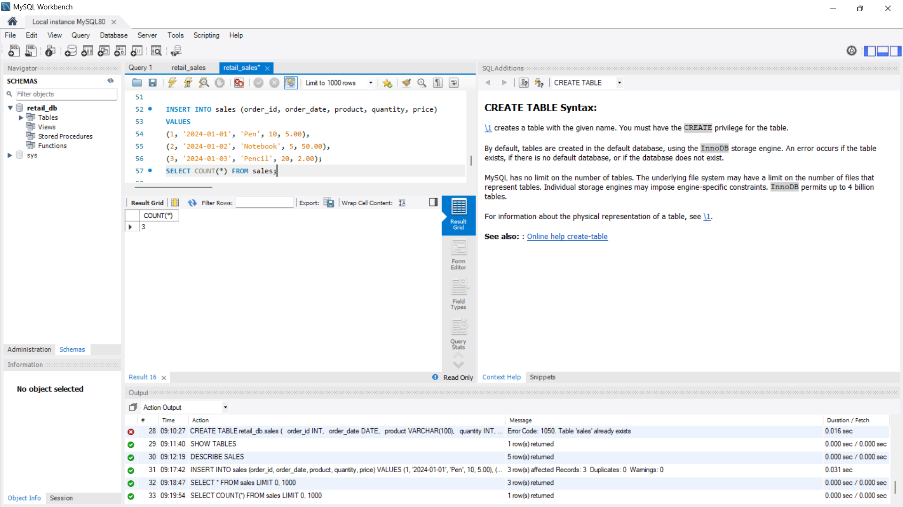

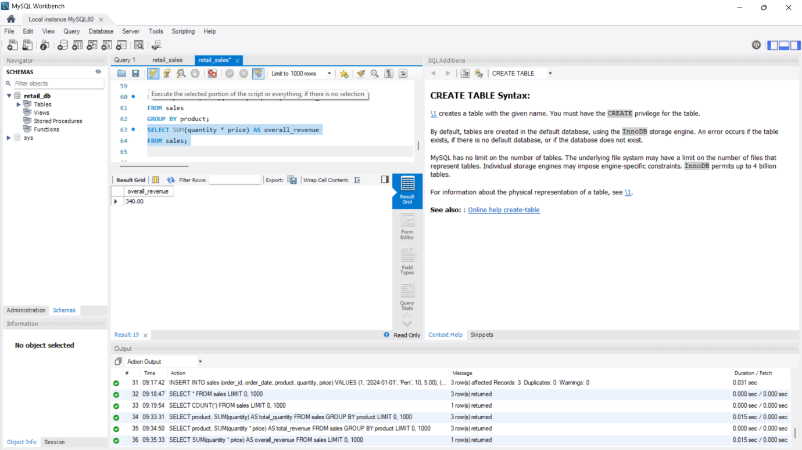
as used to calculate overall revenue by creating a derived column that multiplies the quantity and unit price for each order. Aggregation functions such as SUM() were applied to compute the total revenue generated across all transactions. This approach ensured accurate and consistent revenue calculation directly at the database level, enabling efficient handling of large datasets and reducing dependency on manual calculations.
Further SQL queries were executed to analyze revenue distribution across different product categories. By grouping data using the GROUP BY clause, it was observed that categories with higher unit prices contributed a significant portion of the total revenue despite lower order volumes. This category-level revenue analysis helps identify high-performing products and supports data-driven decisions related to pricing, promotions, and inventory management.
In addition to product category analysis, SQL queries were used to examine revenue on a per-customer basis. By grouping data by Customer_ID and summing the total sales, the analysis identified high-value customers who contribute disproportionately to overall revenue. Understanding customer-level revenue allows businesses to implement targeted marketing strategies, loyalty programs, and personalized offers, maximizing the lifetime value of top customers while encouraging repeat purchases from others.
Moreover, time-based revenue analysis was performed using SQL by extracting the month and year from the Order_Date field and aggregating sales accordingly. This revealed seasonal trends and revenue peaks during specific months or quarters. Such temporal insights help in forecasting demand, planning inventory, and optimizing marketing campaigns to capitalize on high-revenue periods. Combining these time, category, and customer insights provides a comprehensive view of the overall revenue performance, supporting strategic business decision-making.

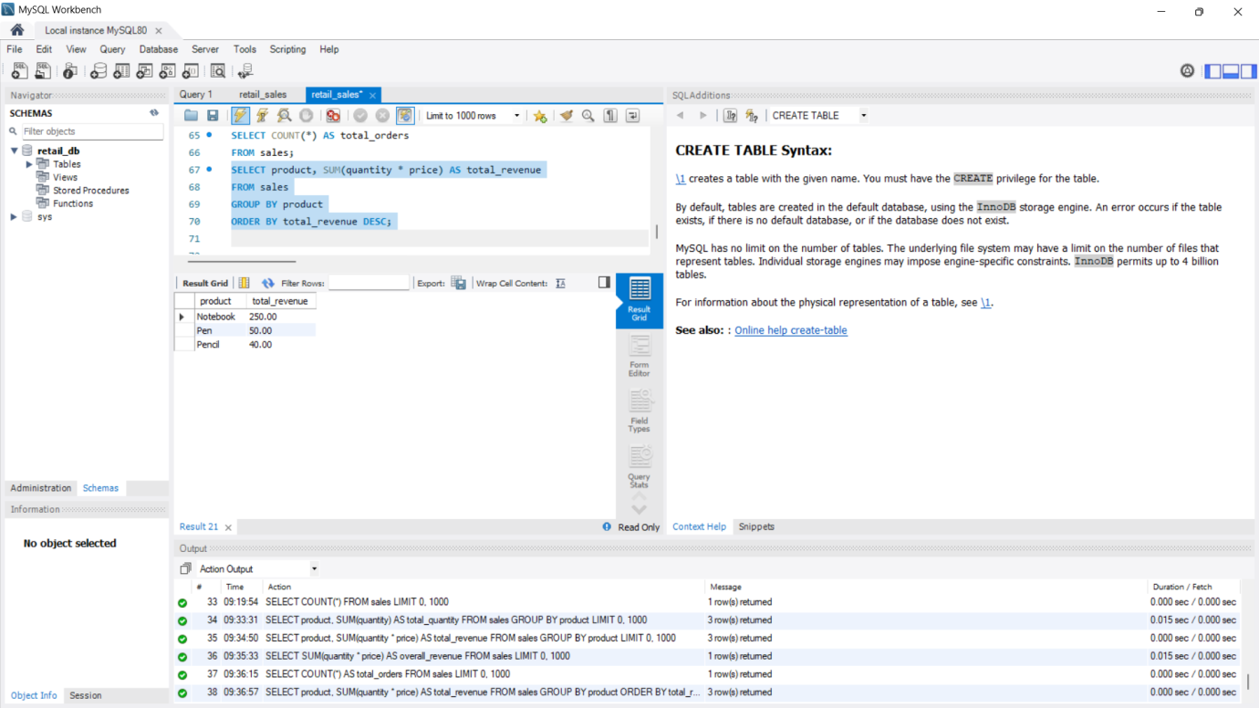

1. Total Revenue Analysis
SQL queries were used to calculate total revenue by creating a derived column:
SELECT SUM(Quantity * UnitPrice) AS TotalRevenue
FROM RetailSales;
Findings:
- Total revenue generated across all transactions was identified.
- High-value transactions were highlighted, contributing significantly to total revenue.
- Ensured accurate revenue calculation at the database level, supporting large dataset processing.

2. Product Category Revenue
Revenue per product category was analyzed using:
SELECT Product_Category, SUM(Quantity * Unit_Price) AS Category_Revenue
FROM Retail_Sales
GROUP BY Product_Category
ORDER BY Category_Revenue DESC;
Findings:
- Electronics and Home & Kitchen categories contributed the highest revenue.
- Low-priced categories required higher order volumes to match revenue.
- Category-level revenue helped identify high-performing products for inventory and marketing focus.

3. Customer-Level Revenue
Customer contributions were analyzed:
SELECT Customer_ID, Customer_Name, SUM(Quantity * Unit_Price) AS Customer_Revenue
FROM Retail_Sales
GROUP BY Customer_ID, Customer_Name
ORDER BY Customer_Revenue DESC;
Findings:
- Top customers contributed disproportionately to total revenue.
- Insights can be used to implement loyalty programs and personalized marketing strategies.
- Identified repeat customers with higher average order value.

4. Store Location Revenue
Revenue across store locations was analyzed:
SELECT Store_Location, SUM(Quantity * Unit_Price) AS Location_Revenue
FROM Retail_Sales
GROUP BY Store_Location
ORDER BY Location_Revenue DESC;
Findings:
- Urban store locations generated higher revenue than semi-urban or rural locations.
- Helps businesses optimize store operations and allocate resources efficiently.

5. Payment Method Revenue
Payment trends were analyzed:
SELECT Payment_Method, SUM(Quantity * Unit_Price) AS Payment_Revenue
FROM Retail_Sales
GROUP BY Payment_Method
ORDER BY Payment_Revenue DESC;
Findings:
- UPI and credit cards were the dominant payment methods.
- Cash payments contributed less to overall revenue.
- Insights assist in promoting digital transactions for faster processing and better customer experience.

6. Time-Based Revenue Analysis
Monthly and yearly revenue trends:
SELECT YEAR(Order_Date) AS Year, MONTH(Order_Date) AS Month,
SUM(Quantity * Unit_Price) AS Monthly_Revenue
FROM Retail_Sales
GROUP BY YEAR(Order_Date), MONTH(Order_Date)
ORDER BY Year, Month;
Findings:
- Seasonal peaks were observed, with higher revenue during festive or high-demand months.
- Enables demand forecasting, inventory planning, and strategic marketing campaigns.

7. Key Insights & Recommendations
- High-Revenue Categories: Focus on electronics and home appliances for promotions.
- Top Customers: Implement loyalty programs for repeat buyers.
- High-Performing Locations: Optimize inventory and staffing in urban stores.
- Payment Trends: Promote digital payments to enhance efficiency.
- Seasonal Trends: Plan targeted campaigns during peak revenue months.
- SQL analysis was performed on the retail sales dataset to extract insights into overall revenue, product performance, customer contributions, store efficiency, and payment trends. Total revenue was calculated by aggregating Quantity × Unit_Price, which highlighted high-value transactions as key contributors. Product category analysis revealed that Electronics and Home & Kitchen generated the highest revenue, while lower-priced categories required higher sales volumes to achieve comparable revenue. These findings provide a clear understanding of which products drive profitability and inform inventory and marketing strategies.
- Customer-level and store-level revenue analysis further demonstrated patterns in purchasing behavior and location performance. By grouping transactions by Customer_ID and Store_Location, SQL queries identified top customers who contribute disproportionately to revenue and urban stores that outperform smaller locations. Payment method analysis showed that digital options like UPI and credit cards dominated revenue, suggesting opportunities to encourage cashless transactions. These insights support targeted marketing, loyalty programs, and operational optimization for high-performing stores.
- Time-based revenue analysis, using year and month extraction from the Order_Date field, revealed seasonal trends and revenue peaks during specific periods. This enables businesses to forecast demand, plan inventory, and strategize marketing campaigns effectively. Overall, SQL provided a comprehensive, scalable, and accurate framework for analyzing multi-dimensional sales data, transforming raw transactional records into actionable insights that support informed business decision-making.

. Exploratory Data Analysis (EDA)

Analysis Conducted
- Total sales by product category
- Sales trend over time
- Customer purchase frequency
- Store-wise sales contribution
- Payment method preference

Key Observations
- Certain product categories generate higher revenue despite lower quantity
- Sales increase during festive/seasonal periods
- Digital payment methods are most preferred
- Urban store locations outperform semi-urban location
POWER BI DAX FORMULAS

1. Total Sales
Function: SUM
Usage: , Charts,
Total Sales =
SUM ( 'Sheet1'[Sales Amount] )

2. Average Sales Value
Function: AVERAGE
Usage: KPI Card (Average transaction value)
Average Sales =
AVERAGE ( 'Sheet1'[Sales Amount] )

3. Total Transactions
Function: COUNT
Usage: Total number of bills / rows (non-unique)
Total Transactions =
COUNT ( 'Sheet1'[order_id] )

4. Unique Counts
Function: DISTINCTCOUNT

Total Orders
Total Orders =
DISTINCTCOUNT ( 'Sheet1'[order_id] )

Total Customers
Total Customers =
DISTINCTCOUNT ( 'Sheet1'[customer_id] )

5. Filtered Sales Calculations
Function: CALCULATE

Category-wise Sales (Electronics Example)
Electronics Sales =
CALCULATE (
[Total Sales],
'Sheet1'[product_category] = "electronics"
)

Year-to-Date Sales
Sales YTD =
CALCULATE (
[Total Sales],
DATESYTD ( 'Sheet1'[order_date] )
)

6. Business Classification
Function: IF
Usage: Legend, Slicer, Table column
Sale Type =
IF (
'Sheet1'[Sales Amount] >= 1000,
"High Sale",
"Low Sale"
)

7. Lookup from Related Table
Function: RELATED
Note: Applicable only when relationships exist
Store Region =
RELATED ( Store[Region] )

8. Percentage Contribution
Function: ALL
Usage: Pie chart, Share of total analysis
Sales % of Total =
DIVIDE (
[Total Sales],
CALCULATE (
[Total Sales],
ALL ( 'Sheet1'[product_category] )
)
)

FINAL VERIFIED FUNCTION SET
SUM
AVERAGE
COUNT
DISTINCTCOUNT
CALCULATE
IF
ALL
RELATED)

Data Analysis Expressions (DAX) is a formula language used in Power BI to create calculated columns, measures, and tables for data analysis. In the given dataset (Sheet1), core DAX functions such as SUM, AVERAGE, COUNT, and DISTINCTCOUNT are used to perform fundamental aggregations on sales data. SUM calculates total revenue using the Sales Amount column, while AVERAGE provides the mean sales value per transaction. COUNT returns the total number of transaction rows, and DISTINCTCOUNT is used to identify business-correct metrics such as unique orders and unique customers. These functions form the foundation of sales reporting and are commonly used in KPI cards, tables, and charts.
ced analysis in Power BI is achieved using functions like CALCULATE, IF, ALL, and RELATED. CALCULATE modifies filter context to compute measures such as category- wise sales or year-to-date sales. The IF function applies business rules to classify data, for example distinguishing high-value and low-value sales. ALL removes existing filters to enable percentage contribution and total comparison analysis. When multiple tables are connected through relationships, RELATED retrieves lookup values from dimension tables. Together, these DAX functions enable dynamic, context-aware analysis and support accurate decision-making in business intelligence reports.

DASH BOARD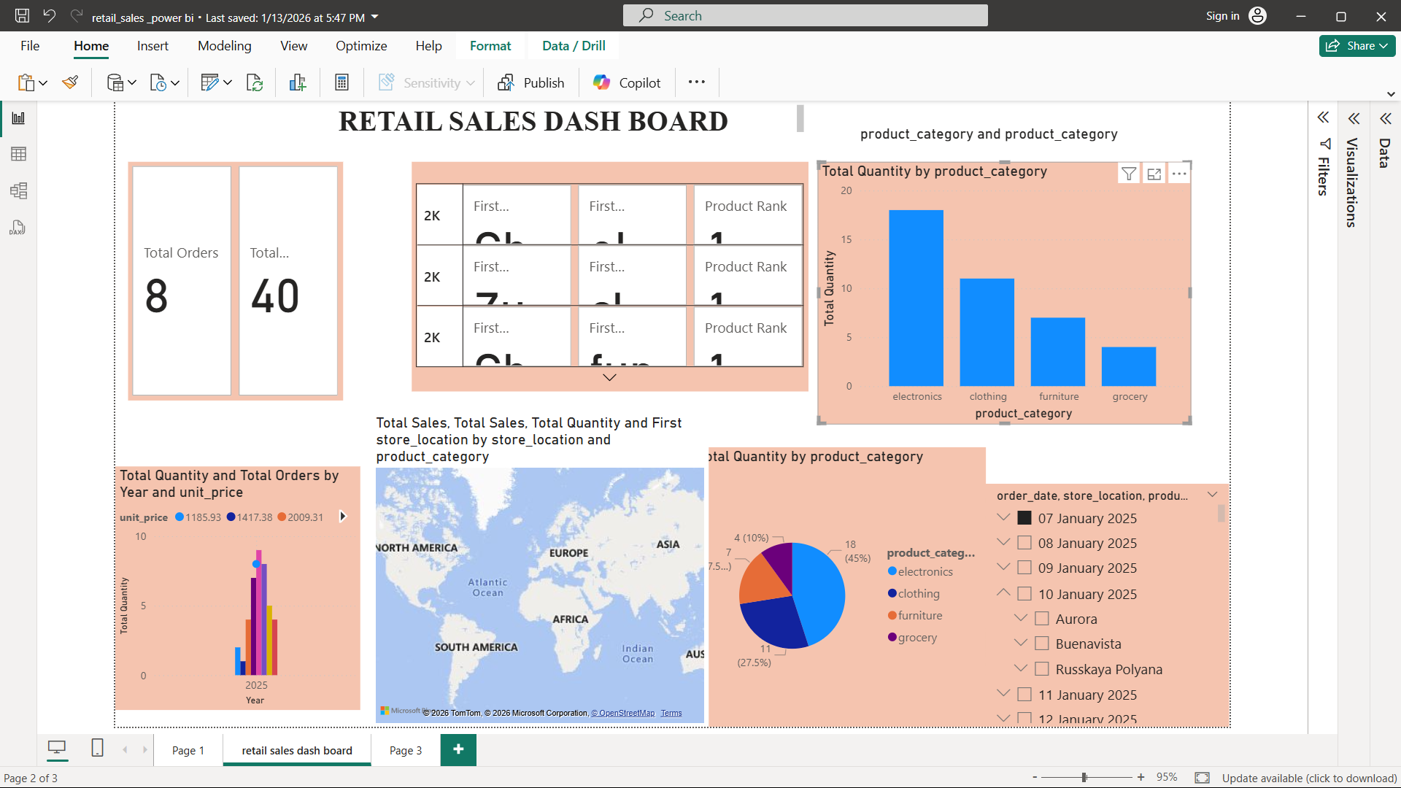

Suggestions
- It is recommended to use measures instead of calculated columns for all aggregation-based metrics such as Total Sales, Average Sales, and Year-to-Date Sales to improve performance and maintain dynamic filter behavior.
- Proper data modeling and relationships should be established between fact and dimension tables (such as Store or Product tables) to effectively use functions like RELATED and to ensure accurate analytical results.
- Business users should consistently use DISTINCTCOUNT for orders and customers to avoid incorrect reporting caused by duplicate transaction rows.
- Date intelligence functions should always be applied using a dedicated date column (order_date) to enable correct time-based analysis such as YTD and trend reporting.

Findings
- The analysis reveals that Total Sales and Sales YTD provide a clear understanding of overall business performance and growth trends.
- Using category-wise and store-wise filtered sales highlights variations in revenue contribution across different product categories and locations.
- The classification of transactions into High Sale and Low Sale helps identify high-value transactions and supports targeted business strategies.
- Percentage contribution analysis using ALL enables easy comparison of each category’s share against the overall sales total.

Conclusion
The application of DAX functions such as SUM, AVERAGE, COUNT, DISTINCTCOUNT, CALCULATE, IF, and ALL enables accurate, dynamic, and business-relevant analysis of the sales dataset. These functions transform raw transactional data into meaningful insights through aggregation, filtering, and contextual evaluation. By following best practices in data modeling and measure creation, Power BI reports can deliver reliable decision support and enhance overall business intelligence effectiveness.

